A

Project Report

is

Submitted to the completion of Epam-COE-DevOPS

Training Program



Submitted By:

Ms. Priyanka Bhardwaj

Junior Software Engineer-Epam Hyderabad

**Task-6 (Building Monitoring for application)**

**For Controller**

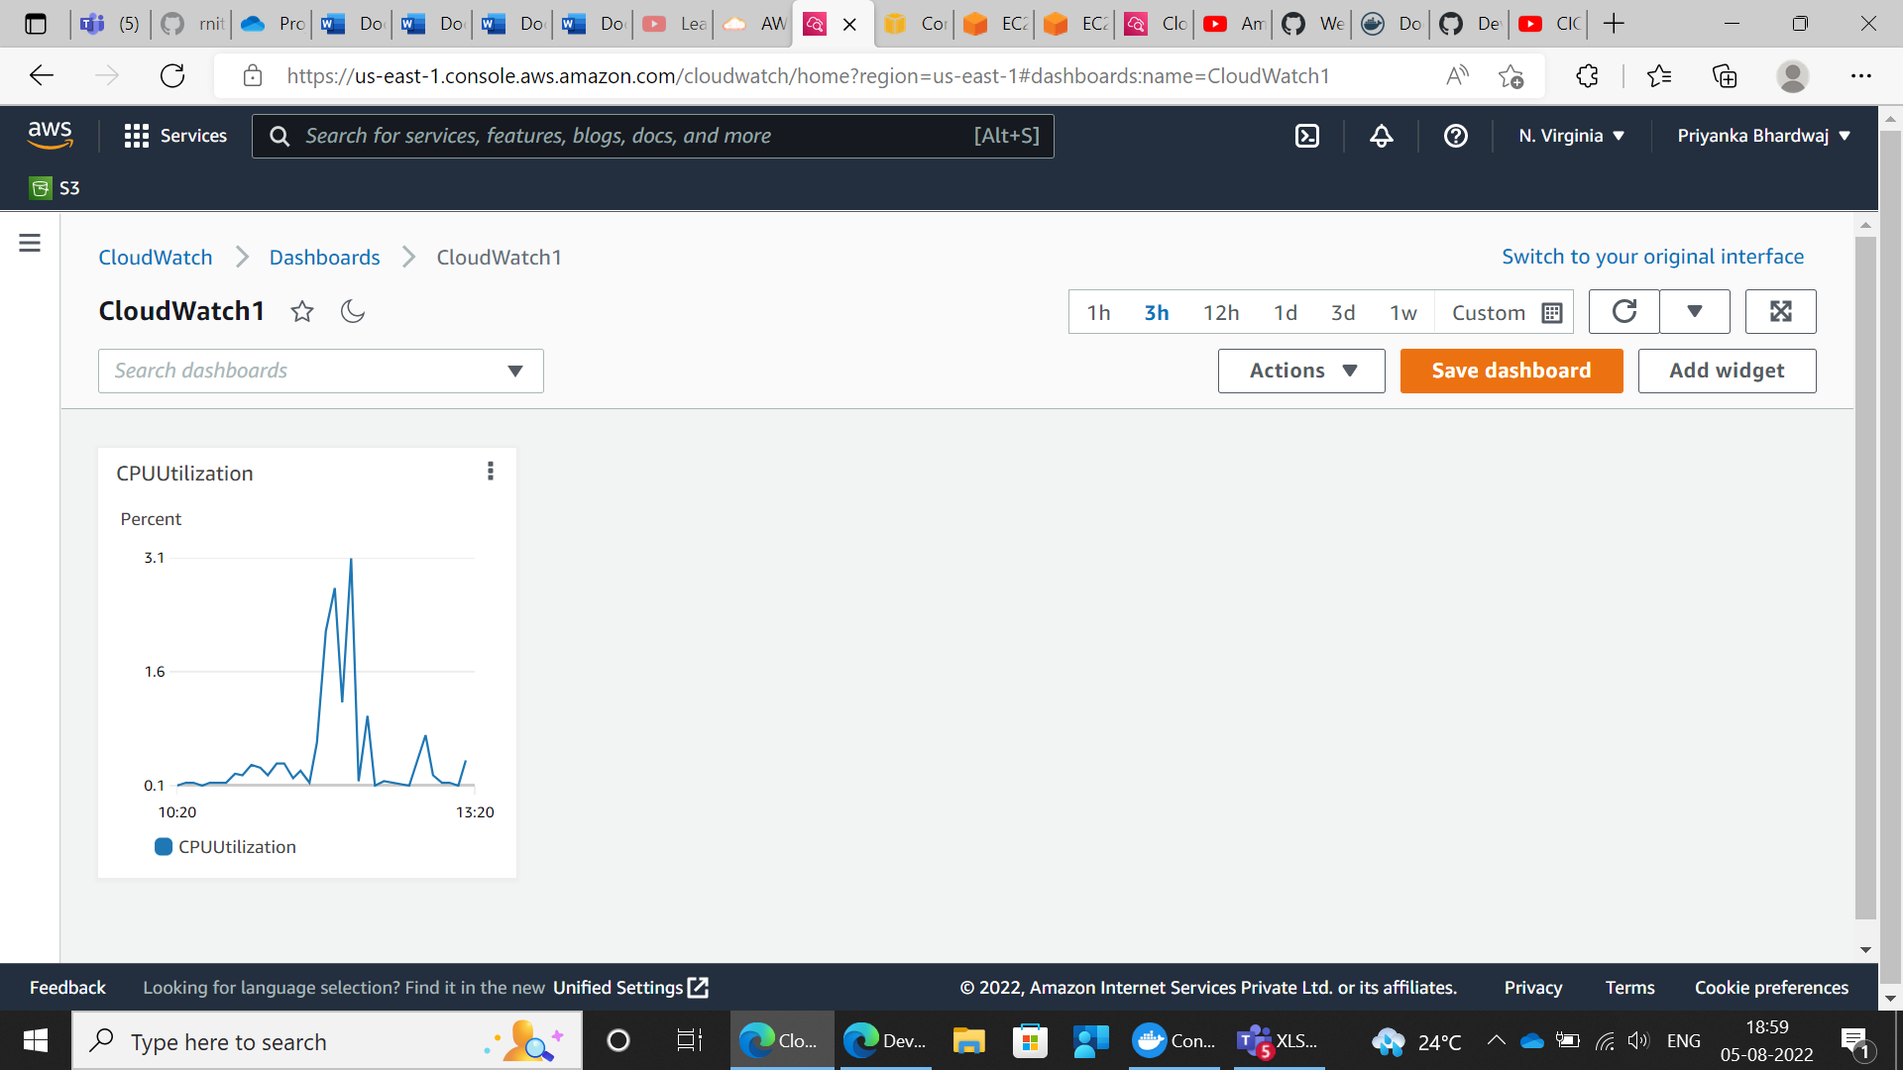

**After Increasing CPU Utilization**

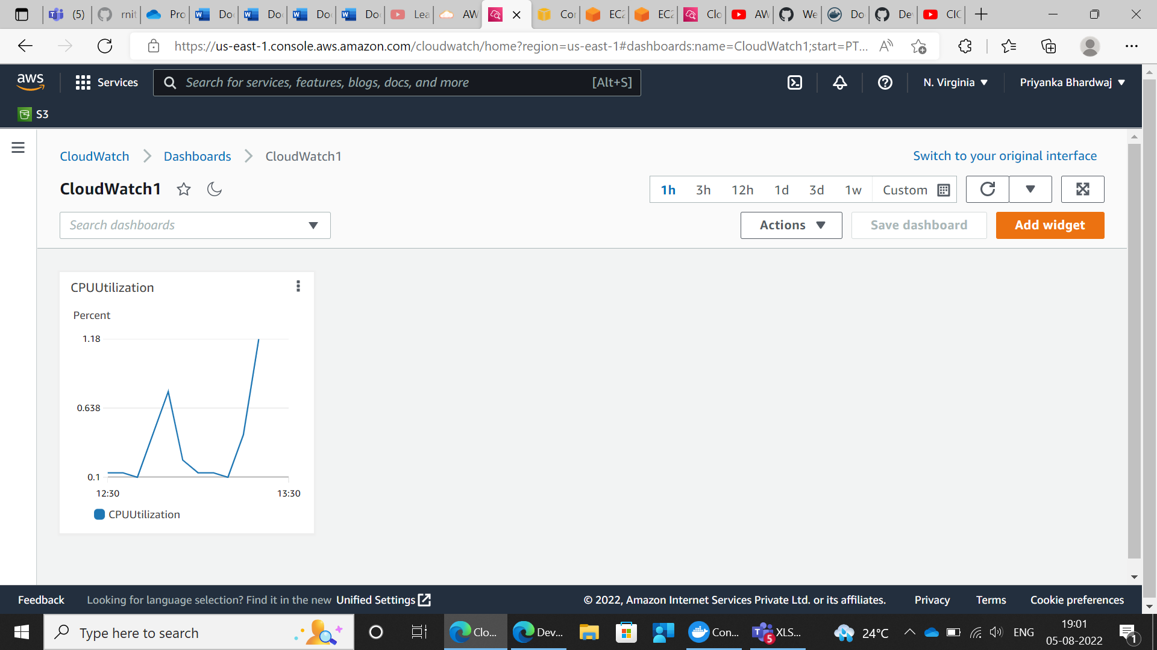

**For Node**

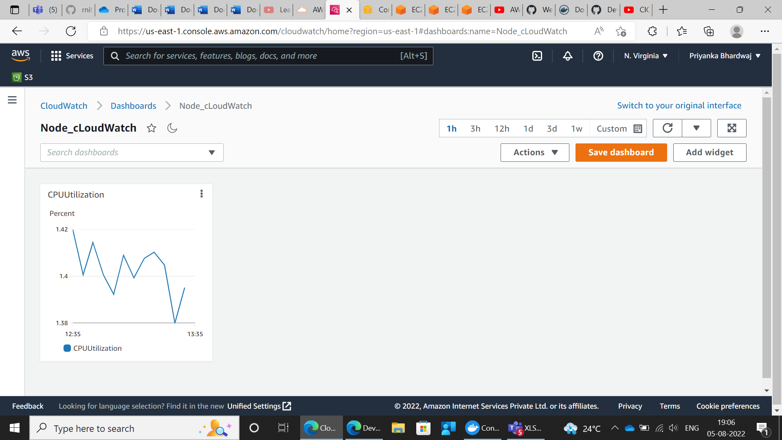

**After CPU Utilization Increased**

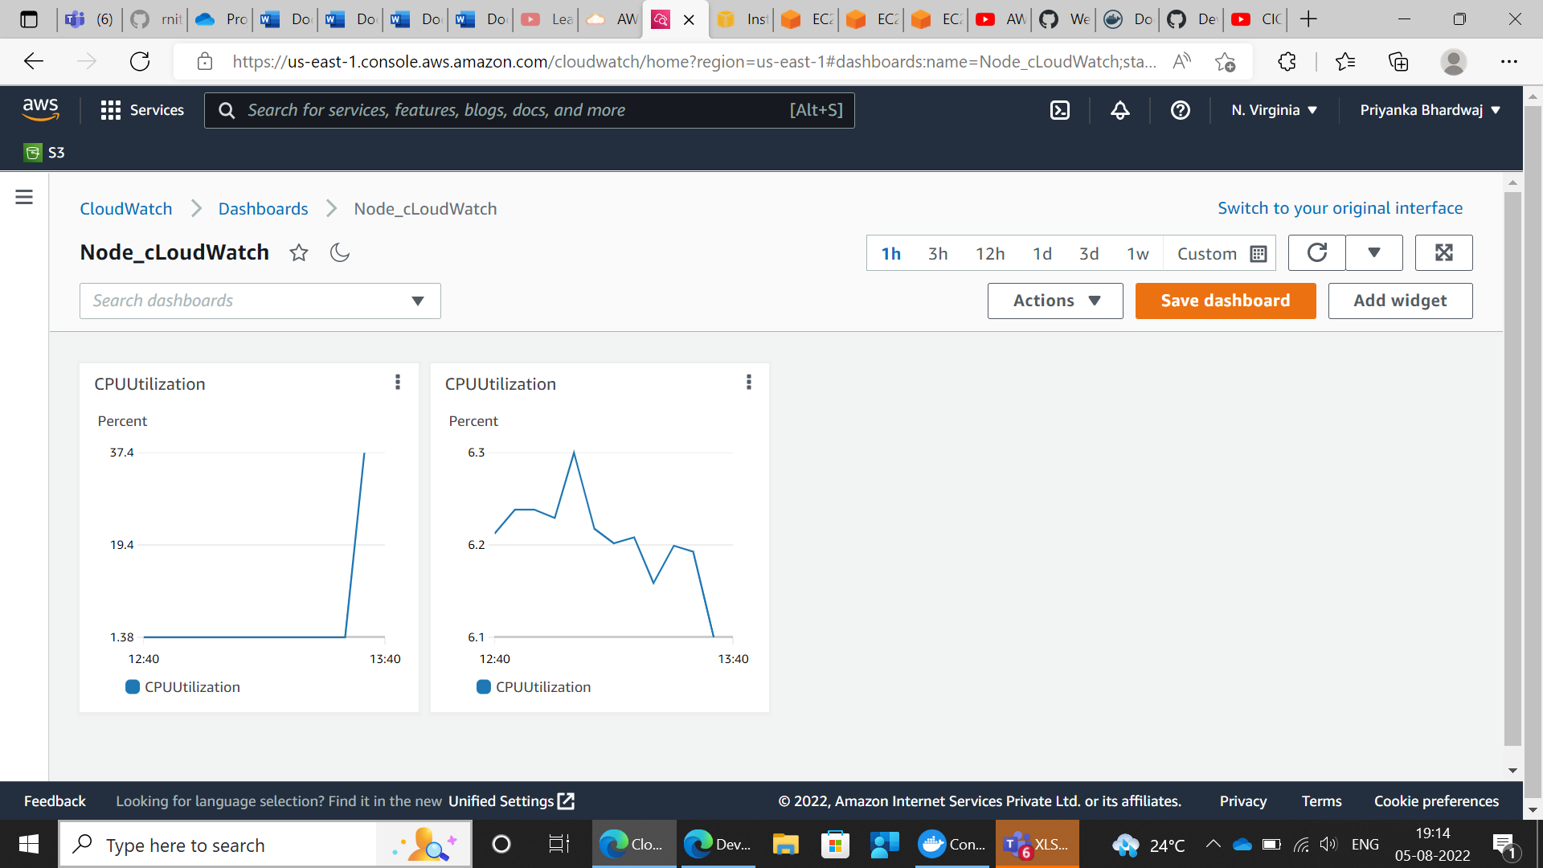

**Master Node**

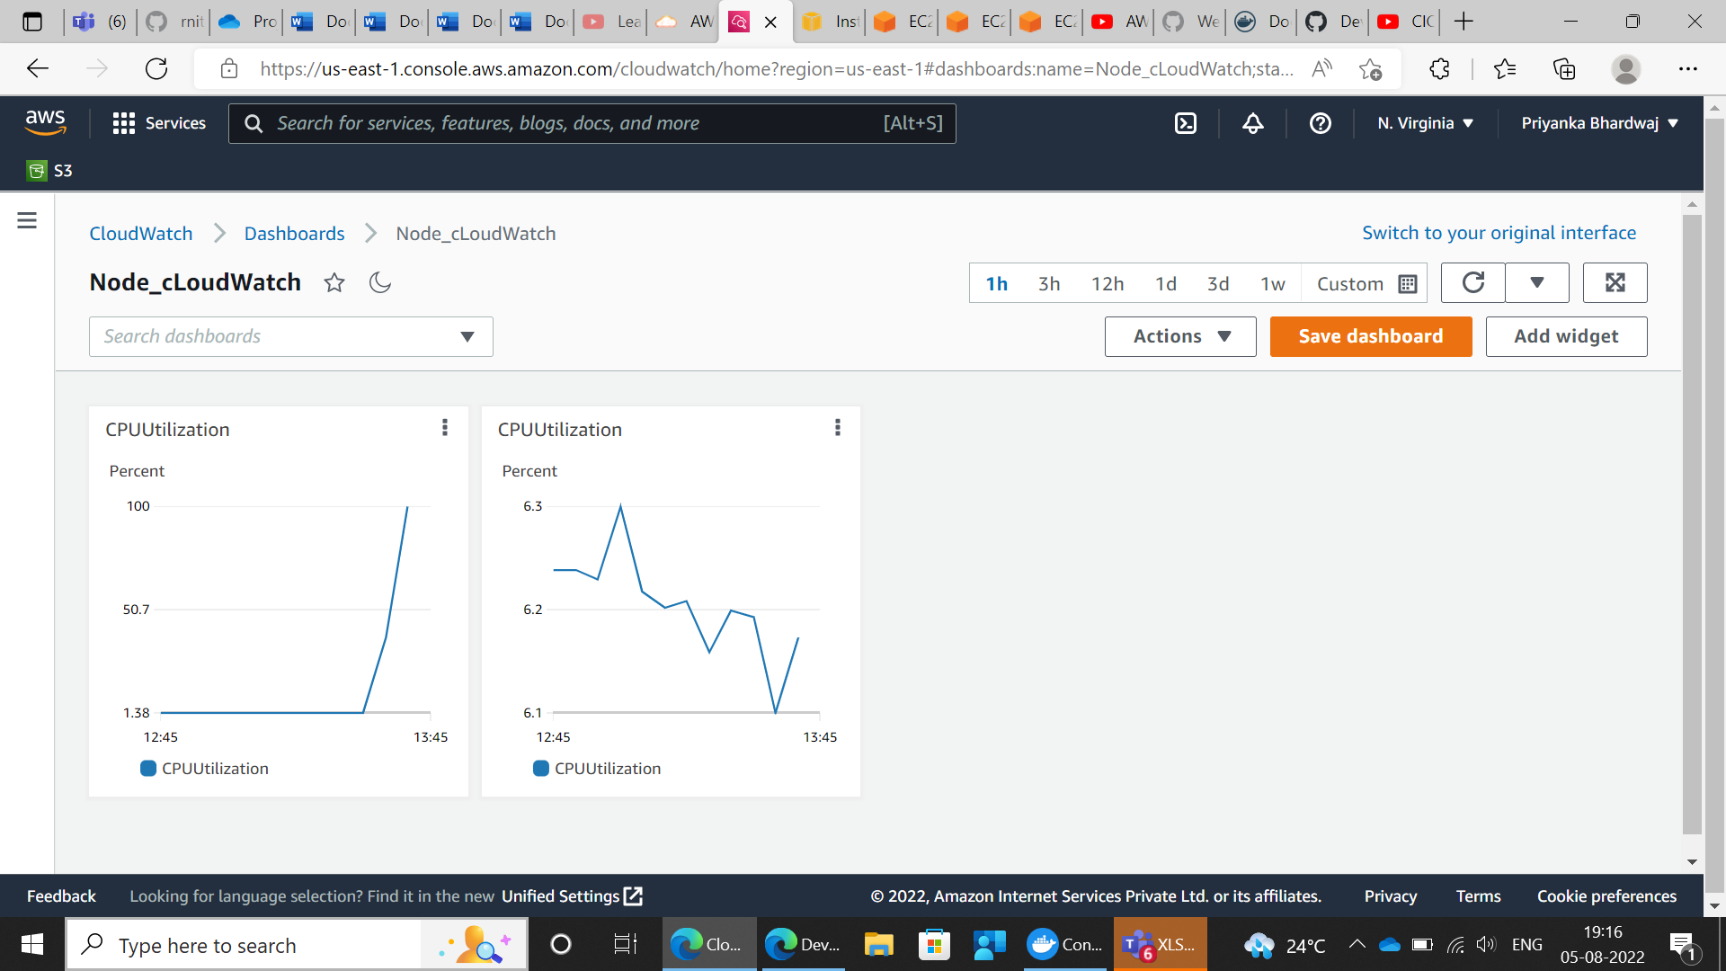

**After CPU Utilization**

